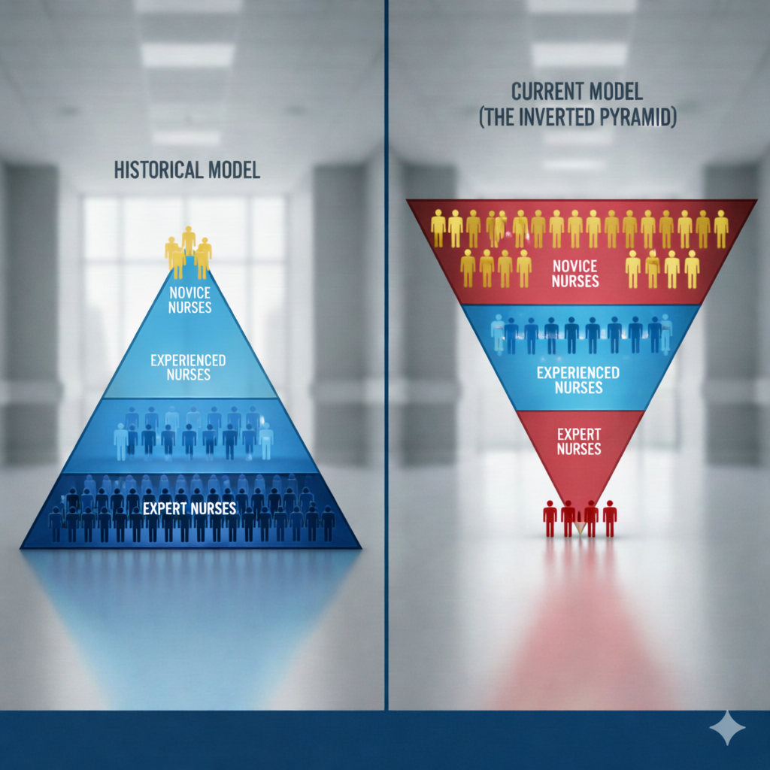  The Inverted Pyramid ™: Leading Teams of Novice Nurses  Nursing faces a structural crisis in many healthcare settings as patient acuity has risen and staff experience has declined. Historically, a solid base of veteran "expert" nurses supported a small group of novices. Today, the model has flipped into an inverted pyramid. Most frontline staff in acute care environments are now novices, supported by a shrinking minority of experienced clinicians. This shift erases "organic learning." Without a middle layer of experience, the burden of decision-making falls heavily on a few seasoned staff and leaders. Clinical intuition is scarce, necessitating explicit protocols, AI-driven alerts, and virtual nursing to prevent errors. This interactive workshop provides leaders and educators with concrete strategies for managing and coaching "clinically young" teams. We will discuss how to build systems of safety and quality that replace traditional mentorship, ensuring high-quality care in an environment where experience is at a premium.
  2 ½ Hour Workshop Offered Virtually or Onsite
  ____
  Affordable Pricing
  ____
  Customized to Your Setting
  ____
  Actionable Tools and Strategies
  ____
  Very Interactive
  Faculty
  Dr. Rose Sherman
  Nationally known for her work in nurse leader development.
  www.emergingrnleader.com
  roseosherman@outlook.com
  (561) 379-5650

The Inverted Pyramid ™: Leading Teams of Novice Nurses
Overview
Nursing leadership is entering a new era. The traditional staffing pyramid — anchored by a deep layer of expert clinicians — has inverted. Today’s acute care units often rely on novice-dense teams supported by a limited experienced core. The leadership approaches that worked in the past assumed informal mentorship, accessible intuition, and layered experiential judgment. Those assumptions no longer consistently hold. The Inverted Pyramid™ framework equips leaders to respond strategically to this structural shift in the workforce. Participants will learn how to reduce cognitive load, engineer safety supports, protect experienced staff from burnout, and rebuild sustainable pathways for clinical growth. This program moves the conversation from “How do we fix novice nurses?” to “How do we redesign systems to match today’s workforce reality?
Workshop Objectives
- Describe the demographic flip and how new generational viewpoints about careers occurring in the nursing workforce are resulting in an Inverted Pyramid.
- Analyze your own unit’s workforce composition and potential risks using the Inverted Pyramid Framework lens.
- Redesign your current leader rounding approach to more effectively coach and support teams of novice nurses.
- Discuss mechanisms to build structural safety and cognitive support, such as clinical decision support huddles, hardwiring nurse vigilance, collective team intelligence, checklists, AI prompts, and virtual nursing.
- Develop one concrete strategy to reduce cognitive overload for novice nurses.
- Provide strategies for managing the “experienced minority” to promote their engagement and prevent them from burning out.
Agenda
9:30 – 10:15 AM The Inverted Pyramid versus Historical Nursing Models
- The shift from a predominantly experienced acute care workforce to an inverted pyramid.
- The evidence on how nurses progress from novice to expert.
- How generational ideas about careers are impacting unit skill mix.
- Doing an Inverted Pyramid unit risk assessment.
- The role of leaders and educators as coaches in the inverted pyramid.
10:15 -10:45 AM Building Cultures of Safety for Novice Nurses
- Promoting critical thinking in novice staff through intentional leader rounding.
- Creating environments of psychological safety where “I don’t know” is a celebrated safety catch.
- Implementing clinical decision support huddles, hardwiring nurse vigilance, and other systems to expedite learning.
- Examining ways that real-time AI prompts, just-in-time nudges, and clinical checklists can help reduce the cognitive load on novices.
- Rethinking the preceptor role in the Inverted Pyramid.
- Educating novice nurses about quality and safety metrics and challenges.
- Q+A
10:45 – 11:00 AM Break
11:00 – 12:00 PM Leadership Strategies to Manage the Inverted Pyramid
- Setting leader boundaries and expectations about accountability and performance.
- Promoting teamwork and collective team intelligence as keys to success in Inverted Pyramids.
- Recognizing staff progress in achieving mastery.
- Leading and retaining your experienced staff.
- Retaining novice nurses as they gain experience.
- Leader Breakout Discussion
- Q+A and Evaluation
Rose O. Sherman, EdD, RN, NEA-BC, FAAN, is nationally known for helping current and future nursing leaders develop leadership and coaching skills. Rose is an emeritus professor at the Christine E. Lynn College of Nursing at Florida Atlantic University and currently serves as a faculty member in the Marian K Shaughnessy Nursing Leadership Academy at Case Western Reserve University. Before becoming a faculty member, she was a nurse leader with the Department of Veterans Affairs for 25 years at five medical centers. Rose edits a popular leadership blog, www.emergingrnleader.com, read by thousands of nurse leaders each week, and was editor-in-chief for ten years of Nurse Leader, the official journal of the American Organization of Nurse Executives. She is a Gallup-certified strengths coach and author of The Nurse Leader Coach: Become the Boss No One Wants to Leave, The Nuts and Bolts of Nursing Leadership, A Team Approach to Nursing Care Delivery, and her newest book, Nursing Leadership in the New World of Work. Rose is a Fellow of the American Academy of Nursing and is an alumnus of the Robert Wood Johnson Executive Nurse Fellowship Program. In 2020, she was selected by the American Association of Critical-Care Nurses for their Pioneering Spirit Award in recognition of her groundbreaking work in nurse leader development. In 2025, the Association for Leadership Science in Nursing recognized Rose with a leadership legacy award for her contributions to the science of nursing leadership.

