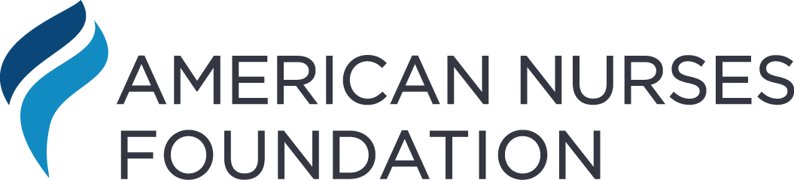
Pulse on the Nation’s Nurses Survey Series: 2022 Workplace Survey
Nurses Not Feeling Heard, Ongoing Staffing and Workplace Issues Contributing to Unhealthy Work Environment
August 2, 2022
It has been over two years since the WHO declared COVID-19 as a pandemic. Yet, the nation’s nurses continue to face unprecedented staffing and workplace issues that are contributing to a shortage of nurses and an increasingly unhealthy work environment. Unchanged from early Foundation pandemic surveys, the emotional health of nurses has remained unchanged, and two-thirds of acute care nurses continue to report feeling stressed, frustrated, and exhausted. Positive feelings, such as feeling supported, fulfilled, and motivated, have declined over the past year. As a continuation of the Pulse on the Nation’s Nurses Survey Series, the American Nurses Foundation has fielded its non-incentivized survey to probe today’s pressing workplace issues and look deeper into today’s challenges. The goal for the 2022 Workplace Survey was to identify the continued impact the pandemic has had on America’s nurses, while collecting additional insight into staffing, scheduling, organizational support, and solutions.
SURVEY BACKGROUND
The American Nurses Foundation and Joslin Insight launched a non-incentivized online survey to nurses across the United States. The June 2022 survey was the first American Nurses Foundation survey focused on the workplace. The Workplace Survey was completed or partially completed by 11,863 nurses, with a ± 1.18% margin of error at a 99% confidence level. Around 86% of those surveyed responded to all questions. Four percent were retired and not included in this data analysis.
RESPONDENT PROFILE
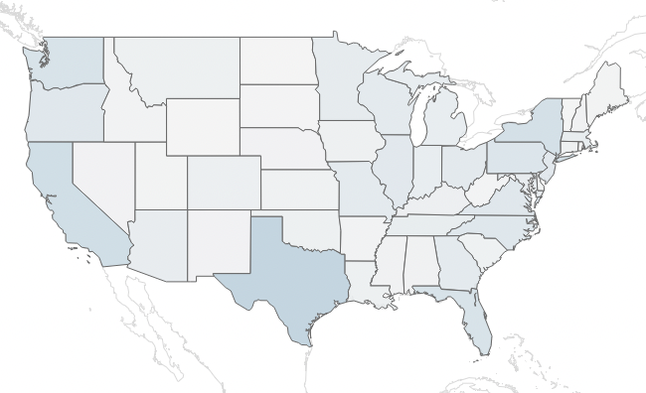
The American Nurses Foundation conducted the Workplace Survey to nurses across the entire continuum of care. Sixty-eight percent identified as White, 11% Black or African American, 6% Asian, 4% Hispanic or Latino, and 4% Mixed race. Thirty-eight percent indicated being 55 or older, an increase from the previous survey. Ninety-four percent indicated being currently employed, with 81% employed full-time. Fifty-eight percent indicated their primary work location is an acute care hospital, small to large; 11% primary, ambulatory, or outpatient care facilities; 5% community or public health facilities; and 5% schools of nursing. Seventy-three percent of respondents indicated that they provide direct care to patients, which was a four-percentage point decrease from the previous Two-Year Impact Assessment. Notably, direct care nurses have historically had lower emotional health scores, higher reports of negative feelings, and higher intent to leave.
Figure 1 – Respondents’ most recent place of employment, June 2022
STAFFING, EXPERTISE, AND CONFIDENCE OFTEN LACKING
In the January 2022 American Nurses Foundation’s Pulse on the Nation’s Nurses Two-Year Impact Assessment, nine-out-of-ten nurses indicated their organization was experiencing a staffing shortage, with 90% classifying it as a serious problem. In this Workplace Survey, a new question was introduced to better understand the severity in terms of the nurses’ skills and knowledge. Nurses were asked how often their unit has the necessary number of RN staff with the right knowledge and skills. For acute care hospitals, 55% of nurses indicated that less than half the time their unit does not have the necessary number. Practically speaking, this means that 28% of the time a patient enters an acute care setting they are likely entering a unit nurses believe is lacking the appropriate staff to provide quality care.
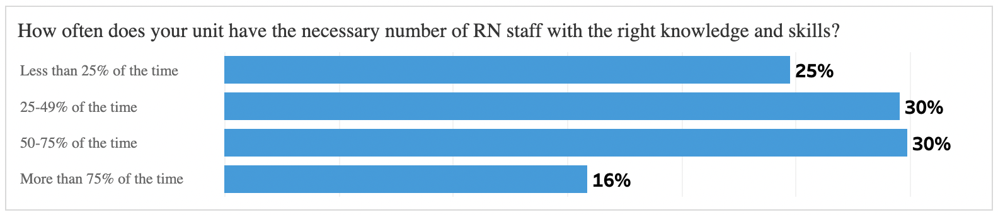
Figure 2 – Acute care nurses indicate how often their unit has the necessary number of staff with the right knowledge and skills, June 2022
The Workplace Survey identified that the shortage also extends to ancillary staff. When asked how often the appropriate ancillary staff is available to support their nursing work, safety, and workflow, 8% said “Always” and 26% “Often, 39% “Sometimes,” 22% “Seldom,” and 5% and “Never.” The numbers worsened for acute care, where appropriate ancillary staff is available Always (6%), Often (23%), Sometimes (42%), Seldom (26%), and Never (4%). And in long-term care facilities the issue is also consistent, with 31% of nurses saying the appropriate support staff is either Seldom (25%) or Never (6%) available.
Appropriate nursing and ancillary staff are often unavailable to patients.
While organizations seek new nurses to fill vacancies, the Workplace Survey identified an underlying concern regarding new nurses’ preparedness. In the survey, nurses with less than two years’ experience were asked whether they feel well prepared to practice on their own. Thirty percent reported that they do not feel well prepared to practice on their own, with 63% “Yes” and 7% “Prefer not to answer.” This is an increasingly critical issue as experienced nurses retire and leave patient care. Educators, regulators, employers, and most importantly patients need practice-ready graduates which will require new models, policy, and investment in change
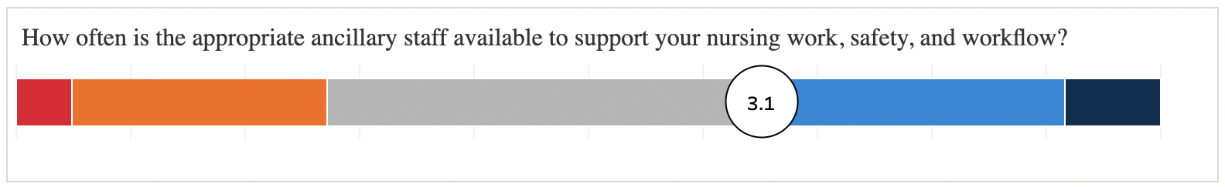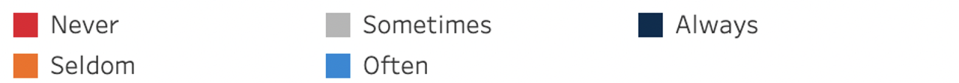
Figure 3 - Nurses indicate how often the appropriate ancillary staff is available to support their nursing work, safety, and workflow, June 2022
59% OF NURSES ASKED TO REGULARLY WORK MORE TO COVER ADDITIONAL SHIFTS WEEKLY
To gauge experiences in the workplace, several questions were asked of nurses to measure time for meals and/or breaks, staffing and scheduling, and the ability to take time off work. When nurses were asked whether they have adequate time for meals and/or breaks, 61% selected “No” and 39% “Yes.” In acute care hospitals, 67% selected “No” and, notably, for nurses with less than two years’ experience, 75% selected “No.”
When asked how often they are asked to cover additional shifts, 59% of nurses replied at least once a week, with 36% indicating being asked weekly and 23% daily. In acute care settings, 69% of nurses said they were asked to cover additional shifts at least once a week, with 41% being asked weekly and 28% daily. Critically, 79% of nurses under 35 in acute care settings indicated that they are asked to cover shifts at least weekly if not daily.
The situation extends to nurses being required to work beyond their shift to finish existing work or provide adequate care to patients. For this Workplace Survey question, 58% of nurses indicated being required to work beyond their shift at least once a week, with 33% weekly and 24% daily. The problem is worse in long-term care facilities, where 76% of nurses said they are required to work beyond their shift at least once a week. And the burden falls even more heavily on nurses under 35 in long-term care facilities, with 86% indicating being required to work beyond their shift at least weekly (50% daily).
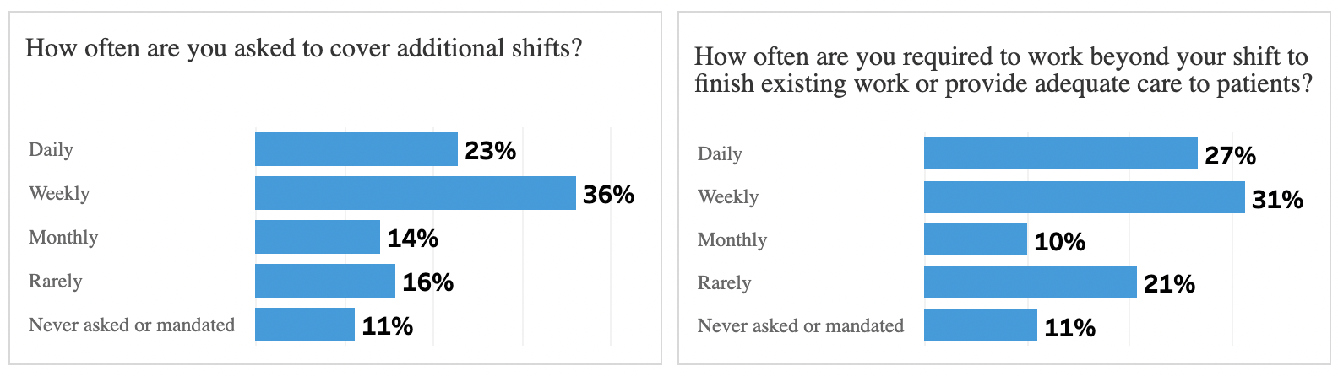
Figure 4 and 5 - Nurses indicate how often they are asked to cover additional shifts or required to work beyond their shift, June 2022
On top of being asked to cover additional shifts and being required to work beyond their shift, nurses are also struggling to find time off work when they request leave. This has only exacerbated the ongoing mental health challenge.
When nurses were asked whether they were able to take time off when requesting leave, 42% said “Yes,” 31% “No,” and 27% “Sometimes.” In acute care settings, the numbers rose slightly to 40% “Yes,” 33% “No,” and 27% “Sometimes.”
The most significant correlation was based on nurses’ years of experience. Nurses with 2-10 years’ tenure felt considerably less able to take time off when requesting leave (34%) when compared to late tenure nurses with 41-50 years’ experience (53%) and 50+ years’ experience (57%).
Figure 6 - Nurses indicate whether they are able to take time off when they request leave, June 2022
Only 42% of Nurses Consider their Work Environment Healthy
Like previous Foundation surveys, respondents were asked to indicate what feelings they have experience in the previous 14 days. In this survey, only 20% of nurses indicated feeling “supported,” 17% “motivated,” and 11% “fulfilled” and “empowered.” In terms of emotional health, the story has not improved. On a 1-5 scale, the score for nurses’ emotional health has gone from 3.0 in the Foundation’s Mental Health and Wellness Three Survey (August 2021), to 3.1 in the Two-Year Impact Assessment (February 2022), to 3.1 in the Workplace Survey (June 2022). The percentage of those who feel “supported” in fact dropped by four percentage points during that time, from 24% in August 2021 to 20% today. The same for feeling “motivated,” which dropped by five percentage points from 22% to 17% over the same 10-month period.
These numbers are supported by Perceived Organizational Support (POS) scores that have been collected regularly during this period. Whether nurses feel their organization “really cares about their wellbeing,” the score remained at 2.9 on a 1-5 scale from August 2021 to June 2022. The same was true for whether nurses feel their organization “responds to their complaints and concerns,” which has remained unchanged at 2.7 since August 2021.
All of this is related to the work environment. When asked whether they consider their work or practice environment to be healthy and/or positive, less than half of the nurses surveyed said “Yes” (42%), with 39% saying “No” and 19% “Not sure.” In acute care settings, the score is worse, with 38% “Yes,” 42% “No,” and 20% “Not sure.” And, notably, long-term care facilities reported the worst scores across all care settings, with 32% “Yes,” 53% “No,” and 15% “Not sure.”
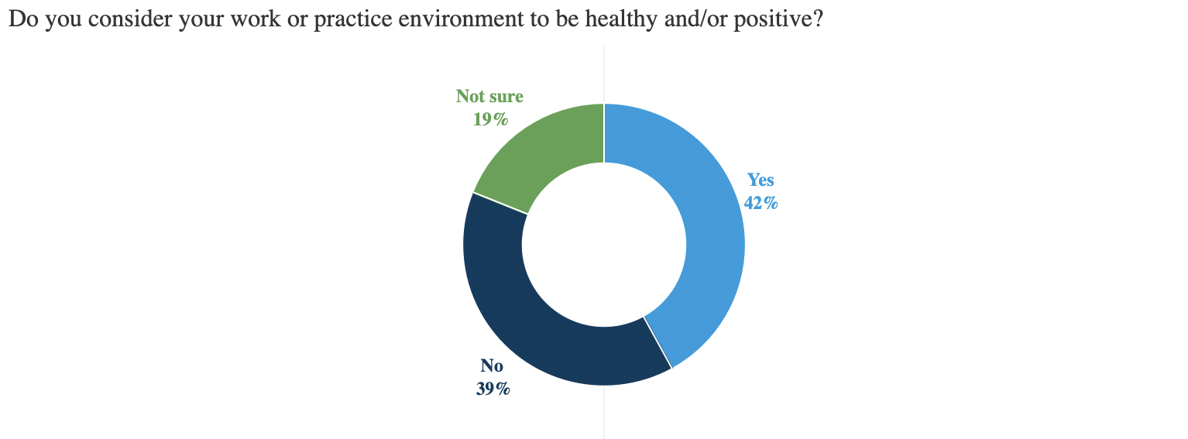
Figure 7 - Nurses indicate whether they consider their work or practice environment to be healthy and/or positive, June 2022
ALARMING WORKPLACE BULLYING, INCIVILITY, AND VIOLENCE
These findings are tied together and are strongly influenced by the prevalence of today’s workplace incivility, bullying, and violence. When asked whether they have experienced one or more incidents of bullying or incivility in the past year, 60% of nurses across all care settings reported “Yes,” they have experienced an incident. For violence, 29% reported having experienced at least one incident. When considering the definition of a healthy work environment, where incidents of violence should be zero, a 29% annual incident rate of violence is an astounding number. And the problem is even worse in acute care, where 65% and 40% of nurses reported experiencing bullying / incivility and violence, respectively.
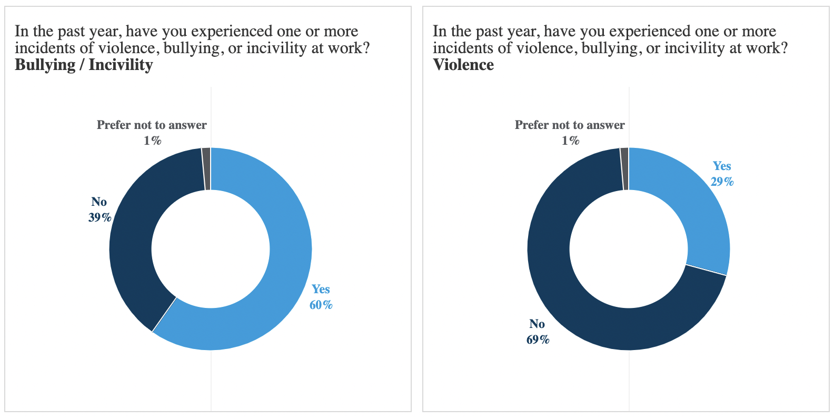
Figures 8 and 9 - Nurses indicate whether they have experienced one or more incidents of violence, bullying, or incivility, June 2022
To make matters worse, the source of violence is coming not only from patients (90%) and patient families (38%), but a surprising number from internal sources, such as other staff nurses (6%), managers and supervisors (4%), and physicians (4%). And while incivility and bullying were once considered more of an internal issue, a significantly high percentage of incidents of bullying and incivility are being attributed to external sources.
When looking at acute care in particular, a glaring data point is the rate of bullying and incivility from physicians, which jumps from 29% in all settings to 37%. As we begin to look at solutions, it is important to note that a statistically significant percentage of nurses in unhealthy work environments indicated that creating an anti-bullying program or implementing a no-tolerance workplace violence policy would improve their overall work satisfaction.
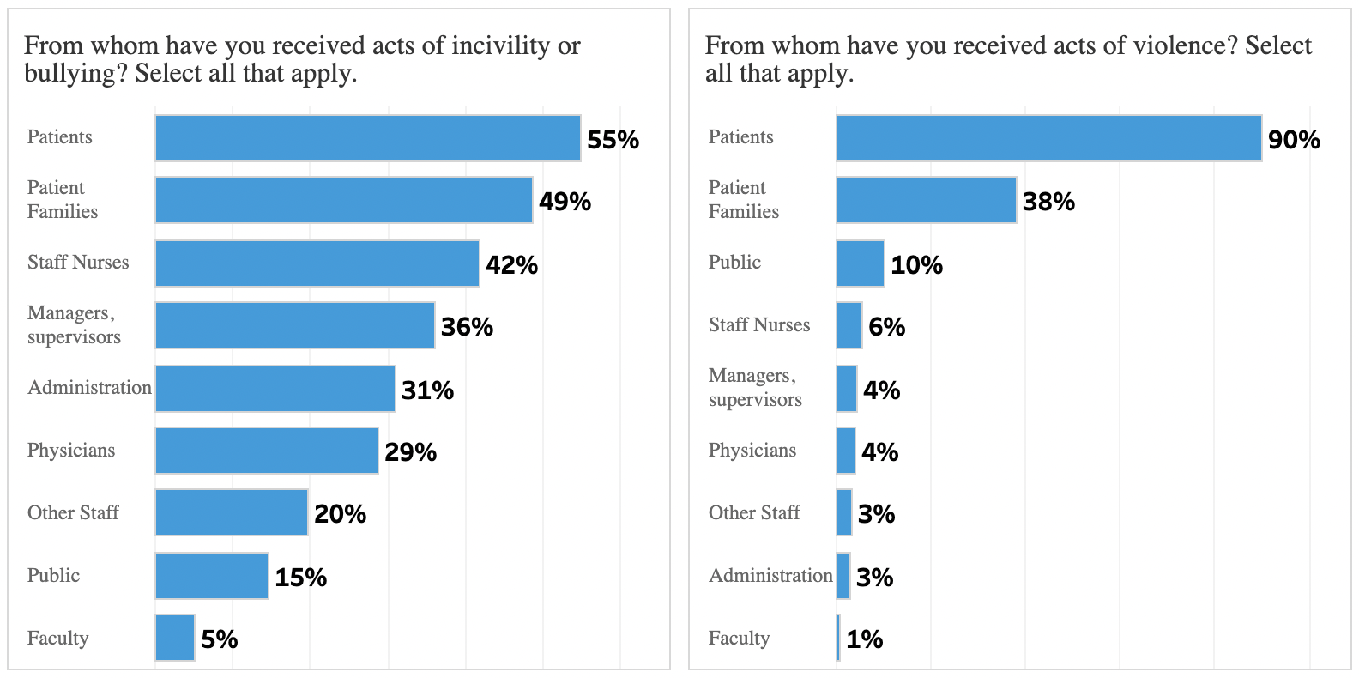
Figures 10 and 11 - Nurses indicate from where they have received acts of violence, bullying, or incivility, June 2022
THINGS MUST GET BETTER
Numerous studies have been conducted since the start of the pandemic, and a plethora of national data is accessible to organizations to improve their work environment. But is the data being acted on?
Today, intent to leave remains high. In the Two-Year Impact Assessment, 23% of nurses indicated they were intending to leave their current position, with 29% indicating “Maybe,” that they were considering leaving their current position in the next six months. For the Workplace Survey, the language of the question was refined to capture intent to leave direct patient care specifically and asked only of direct patient care nurses. The numbers remain elevated with 19% indicating intent to leave direct patient care in the next six months, and another 30% indicating considering leaving. In short, nearly half (49%) of direct patient care nurses are currently planning to leave or considering leaving direct patient care.
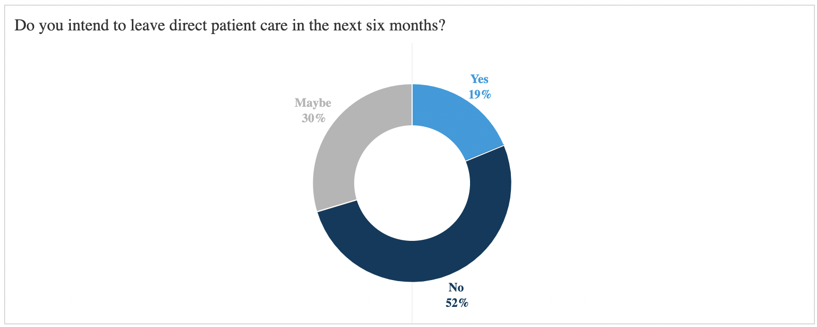
Figure 12 - Direct patient care nurses indicate intent to leave direct patient care in the next six months, June 2022
In both the Foundation’s Two-Year Impact Assessment (January 2022) and this Workplace Survey, nurses were asked what their organization could do to increase their overall work satisfaction. Increasing salary and number of nurses and support staff remained high over the quarter between the surveys, rising four and five percentage points to 68% and 59% respectively. But a new addition to the Workplace Survey stood out. When asked how their organization could improve their overall work satisfaction, 31% of nurses selected “Genuinely listen to my voice and respond to my needs.”
When looking at correlations to other datasets, such as emotional health and healthy work environments, the importance of genuinely listening to nurses’ voices becomes even more critical. Of respondents who indicated they are not or not at all emotionally healthy, a statistically significant 36% said that leaders genuinely listening to their voice and responding to their needs would improve their work satisfaction. And of respondents who said their work environment was unhealthy, a statistically significant 39% indicated the same.
In addition, nurses were asked to agree or disagree with potential outcomes if they were to ask for help with stress at work. On a 1-5 scale, the score was a 2.6 for “I would feel heard and understood.” For the nurses who indicated their work environment was unhealthy, 2.3 disagreed or strongly disagreed that they would feel heard or understood if they asked for help with their stress. The correlations imply that genuinely listening to the nurse’s voice and responding to their needs is directly linked to their overall work satisfaction, emotional health, and the health of their work environment.
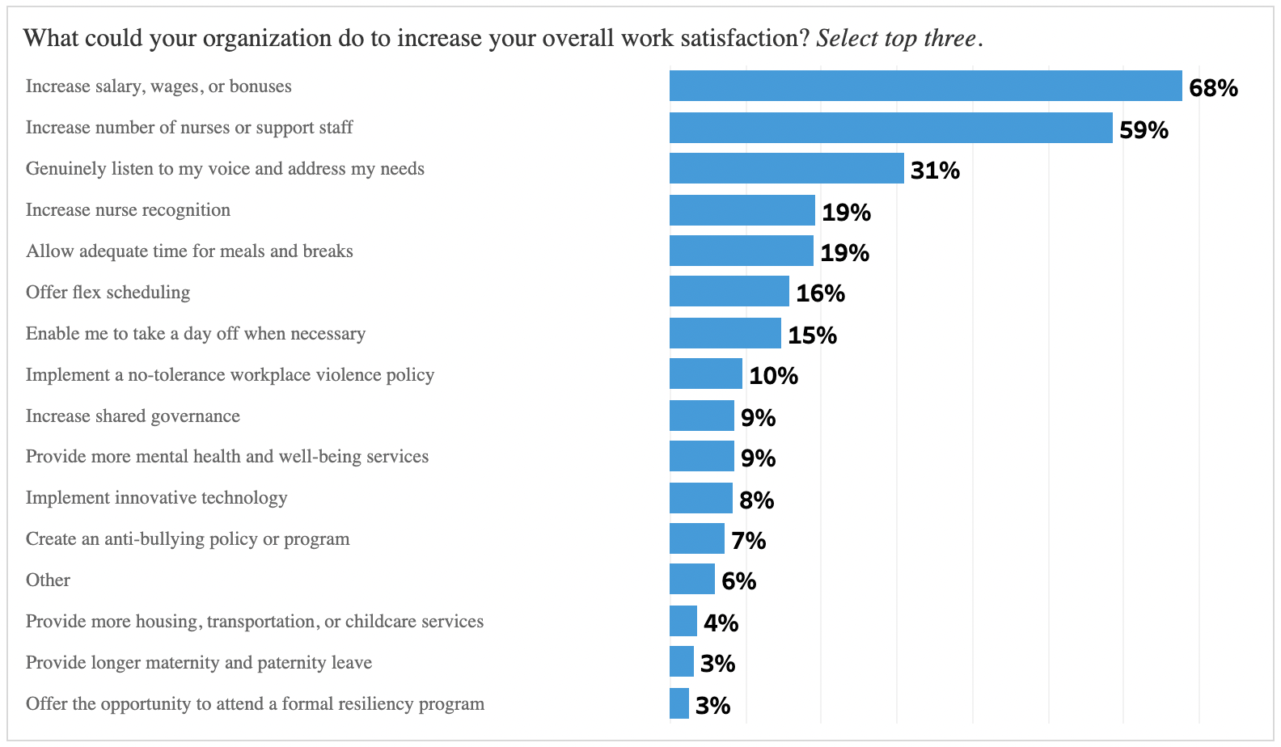
Figure 13 – Nurses indicate what their organization could do to increase their overall work satisfaction, June 2022
SEEKING MEANINGFUL SOLUTIONS
As we analyze the data, including other datasets from the Workplace Survey not included in this report, it is evident that the state of nursing today remains tenuous at best. The numbers show that bullying, incivility, and violence are widespread; emotional health of nurses remains at unhealthy levels; and feelings of stress, frustration, and exhaustion are still elevated two years after the onset of the pandemic. The numbers also reveal that positive feelings, which lead to commitment and performance, have stagnated. Nurses report practicing in workplaces without the necessary number of RN staff with the right knowledge and skills and almost half in the survey are planning to or considering leaving direct patient care.
Critical to ensuring we have the expert nurses we need as a society will require addressing nurses concerns with urgency, investing in new solutions, and ensuring that healthcare organizations rebuild the workplace to foster employees’ long-term commitment and focus on reclaiming positive feelings by aiming to uplift and inspire the whole person. This requires a shift centered on the substantive and various needs of the workforce.
The newly formed National Taskforce on Nurse Staffing has identified short-term actionable solutions that can be implemented and measured in 12 to 18 months. It begins with listening to nurses and fully engaging them as true partners in solving workplace problems – from supply chain to how care is organized and delivered. It begins with truly listening to nurses’ experiences and committing to investing in new ways of doing things and shifting how dollars are spent.
Ensuring that nurses can deliver the care that patients need will require nurses are themselves psychologically and physically safe and supported in a healthy work environment. Their health and well-being must be an organizational priority and events of high stress, moral injury and burnout are addressed in an ongoing manner. They must have appropriate staffing and a system of support – who are compensated fairly to provide quality care. Nurses must have the ability to practice to their full scope and potential. They need more flexibility in how, when and where they work. And their workplaces must intentionally and systematically integrate diversity, equity, inclusion, and belonging through proper planning, operations, and resource allocations. Finally, they must be true partners in making critical organizational and direct-care decisions including how, where, and when care is delivered that is fully responsive to patient needs.
This will require both reprioritizing current investments in care delivery and making new financial investments in the workforce and the workplace. While spending the most on health care globally, the United States health care system has consistently underinvested in nursing and nurses paying for that with their own health. The world has forever been changed by the pandemic and how nurses are valued must be as well.

