Using the Circle of Influence with Your Staff

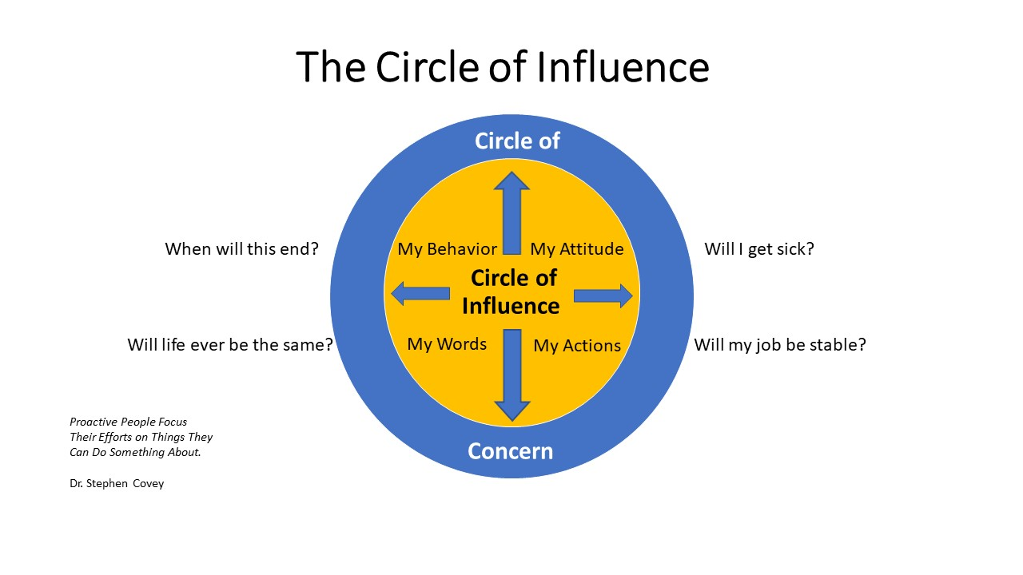
- Is this issue we are discussing in your circle of influence or circle of concern?

- What can you do within your circle of influence to impact this situation?

- How could implementing that behavior push out your circle of influence in this situation?

- What do you know you could be doing in this situation but are not yet taking action?

- What could be the consequences here if you fail to change your behavior?

